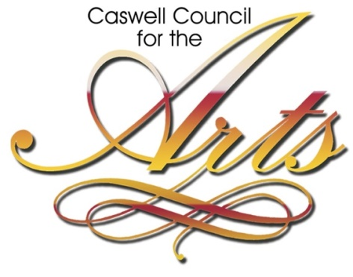 | Mailing Address:  PO Box 689  Yanceyville, NC 27379  Gallery at 43 W. Main St.  Yanceyville, NC 27379  (336) 694-4474  caswellarts@gmail.com

The Caswell Council for the Arts is currently accepting applications from artists of all varieties (2D and 3D) who wish to exhibit in the Lee Fowlkes Gallery in 2019. Whether you wish to exhibit an entire show or just a few pieces, all artists are encouraged to apply. Artists will be chosen from all applicants received by August 10th.
You may apply online at ccfta.org (click on gallery) or fill out this page and deliver to our mailing address above. Please include the following:
Name_____________________________________________________________
Address___________________________________________________________
City ___________________________________State ____ Zip ___________
Phone _________________________________
Medium of Work: _______________________________________
Brief description of your work: (max 250 characters) ____________________________________________________________________________________________________________________________________________________________
______________________________________________________________________________
Your website (optional if you have one): _______________________________________
Please check ALL that apply:
I am interested in a full show (approx. 30+ pieces) Yes ___ No ____
I am interested in being a featured artist (approx. 12-18 pieces) Yes ____ No ______
I am interested in being included in a group show (approx. 1-3 pieces) Yes ____ No _____
Please Attach Artist Bio or Artist Statement (optional but helpful, especially if you would like to be considered for a full show or as a featured artist)
Application must include at least 3 images of your work (digital images can be emailed to caswellarts@gmail.com). Images do not need to be professional quality. They just need to be able to show us some samples of your work. If you would prefer to bring some work by for us to view instead, please call Denise at (919) 694-4474 to make an appointment. Thanks.

